INDUSTRY INTERNSHIP REPORT
On


“Java Fullstack”
An Internship report submitted in partial fulfillment of requirements for the award of degree of
BACHELOR OF TECHNOLOGY
COMPUTER SCIENCE AND ENGINEERING

By
Gali Iswarya (239X5A05L4)
Under the esteemed guidance of P.Sunandha
Associate Professor Department of C.S.E.

Department of Computer Science and Engineering

G. PULLA REDDY ENGINEERING COLLEGE (Autonomous): KURNOOL
(Affiliated to JNTUA,Ananthapuramu)
KURNOOL – 518007
2025 – 2026

Department of Computer Science and Engineering

G. PULLA REDDY ENGINEERING COLLEGE (Autonomous): KURNOOL
(Affiliated to JNTUA, ANANTHAPURAMU)



CERTIFICATE

This is to certify that the internship titled ‘Java Fullstack’ is a bonafide record of work carried out by Gali Iswarya (239X5A05L4) and the Internship report is submitted in partial fulfillment of requirements for the award of degree of Bachelor of Technology in Computer Science and Engineering.

…………………………….. . ……………………………..
P.Sunandha Dr. N. Kasiviswanath
Associate Professor Professor & Head of the Department,
Department of C.S.E., Department of C.S.E.,
G. Pulla Reddy Engineering College, G. Pulla Reddy Engineering College,
Kurnool. Kurnool.

INTERNSHIP DETAILS

Name of the College : G. Pulla Reddy Engineering College
Department : Computer Science and Engineering
Name of the Student : Gali Iswarya
Register Number : 239X5A05L4
Name of the Guide : Mr. S Monsoor Ali
Duration of the Internship : From 15-12-2025 to 10-04-2026
Name and address of the Organization : codeon technologies, reddy bhavan line, karkambadi road, Tirupati, 517501
Internship Domain : Java Fullsatck
Internship Stipend : No Stipend
Date of Internship Report Submission : 18-04-2026

Internship Coordinator
Dr. B. Geetha Vani Professor
CSE Department GPREC

DECLARATION

I Gali Iswarya, a student bearing the Roll No. 239X5A05L4, of the Department of Computer Science and Engineering, G. Pulla Reddy Engineering College, do hereby declare that the I have completed the mandatory internship Java Full Stack from 15-12-2025 to 10-04-2026 in Codeon Technologies under the Guide ship of Mr. S Mansoor Ali.

(Student Signature and Date)

Certificate from Organization
This is to certify that Gali Iswarya 239X5A05L4 of G. Pulla Reddy Engineering College underwent Internship in Codeon Technologies from 15-12-2025 to 10-04-2026.

The overall performance of the Intern during her internship is found to be good.

Authorized Signatory with Date and Seal

Internship completion certificate

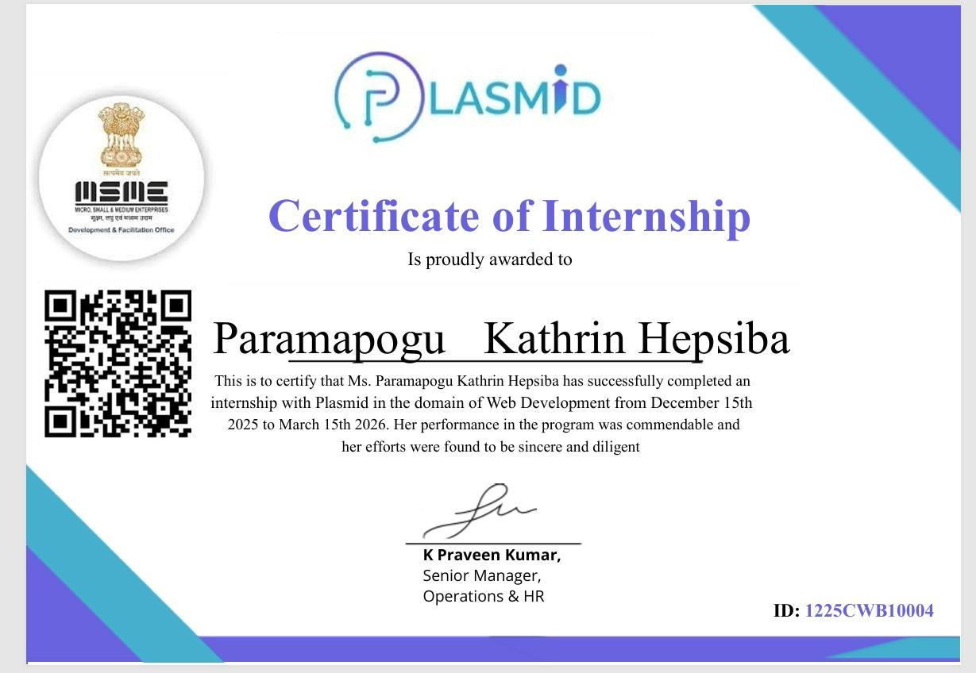

ACKNOWLEDGEMENT

I wish to express my deep sense of gratitude to my internal supervisor P.Sunandha, Associate Professor of Computer Science and Engineering Department, G. Pulla Reddy Engineering College.
My sincere thanks to our Internship Coordinator Dr. B. Geetha Vani, Professor of CSE for her immaculate guidance, constant encouragement and cooperation which have made possible to bring out this internship work.
My sincere thanks to Mr. S Mansoor Ali, Technical Mentor, of Codeon Technologies, for helping me and giving me the required information needed for my internship work.
I am thankful to our Head of the Department Dr. N. Kasiviswanath, for his whole hearted support and encouragement during the internship.
We are grateful to our Internship Dean Dr. Y. V. Siva Reddy and to our respected Principal Dr. B. Sreenivasa Reddy for providing requisite facilities and helping us in providing such a good environment.
I wish to convey my acknowledgements to all the staff members of the Computer Science and Engineering Department for giving the required information needed for my internship work.
Finally, I wish to thank all our friends and well-wishers who have helped me directly or indirectly during the course of this internship work.

Table of Contents

CHAPTER Page No
- INTRODUCTION
  - About the Internship Company/Organization 1
  - Virtual/Offline Internship details 4
- WORK DONE DURING INTERNSHIP
  - About Course/Domain 8
  - Technologies learnt during internship 16
- PROJECTS/MODULES COMPLETED
  - About Project 19
- ACTIVITY LOG 43
- CONCLUSION 48
- REFERENCES 50

List of Figures

FIGURE NO. FIGURE NAME
Figure 3.1.1 | Architecture of Employee Management System (Frontend–Backend–Database Interaction)
Figure 3.1.2 | React Component Structure for Employee Form
Figure 3.1.3 | Database Schema Diagram for Employee and Department Tables
Figure 3.1.4 | Flowchart of CRUD Operations in EMS
Figure 3.1.5 | Unit Testing Workflow for EMS
Figure 3.2.1 | EMI Calculator User Interface Layout (HTML & CSS)
Figure 3.2.2 | JavaScript Logic Flow for EMI Calculation
Figure 3.2.3 | Pie Chart Visualization of Principal vs. Interest
Figure 3.2.4 | Speedometer Indicator for Loan Risk Categories
Figure 3.2.5 | Bar Chart Representation of Loan Repayment Schedule
Figure 3.2.6 | Sample Output Table Generated by EMI Calculator
Figure 3.2.7 | Code Implementation Snippet for EMI Formula in JavaScript

1.INTRODUCTION

About the Internship Company/Organization:

The internship was carried out at Codeon Technologies Pvt. Ltd., a technology-driven organization founded in 2019 and headquartered in Tirupati, India. The company has established itself as a reliable provider of innovative software solutions and industry-oriented training, with a strong focus on developing smart, scalable, and future-ready SaaS applications. Codeon Technologies collaborates with startups, enterprises, and government organizations to deliver customized software solutions, cloud-based platforms, AI-driven tools, and end-to-end full-stack development services.

The organization operates with a clear vision of driving digital transformation by building efficient and intelligent software systems. With a team of experienced professionals, including developers, designers, and technical mentors, Codeon Technologies emphasizes quality, scalability, and innovation in every solution it delivers. The company not only focuses on product development but also plays a vital role in shaping future software engineers by providing practical and industry-relevant training programs.

A key highlight of Codeon Technologies is its Java Full Stack Development training program, which is designed to bridge the gap between academic knowledge and real-world industry requirements. The curriculum is comprehensive and structured, covering a wide range of technologies such as Core Java, Advanced Java, JDBC, Servlets, JSP, and modern frameworks like Spring and Spring Boot. In addition to back-end technologies, the program also includes front-end development using HTML, CSS, JavaScript, and Bootstrap, along with database management systems. This integrated approach ensures that students gain a complete understanding of both client-side and server-side development.

The training methodology adopted by the company strongly emphasizes hands-on learning and real-time project development. Instead of focusing only on theoretical concepts, students are encouraged to implement their knowledge through coding exercises, assignments, and real-world projects. This approach helps in building strong problem-solving skills, logical thinking, and confidence in developing scalable applications.

As part of the internship, students gain practical exposure by working on projects that simulate real-world applications. One such project is a Temperature Converter web application, developed using HTML, CSS, JavaScript, and Bootstrap, which was further enhanced by integrating the OpenWeather API to fetch real-time temperature data. This project helped in understanding API integration, responsive UI design, and client-side logic implementation.

In addition, a major Java Full Stack project titled “Sphere” was developed, which is a unified project management system similar to platforms like Jira. This application enables users to manage tasks, track progress, and collaborate within teams. It also introduces Agile working principles by incorporating Scrumban-based features, allowing users to organize workflows, monitor sprint activities, and understand how real-world project environments operate.

Through such projects, Codeon Technologies ensures that students gain real-world hands-on experience, making them industry-ready and capable of adapting to professional environments with ease. The organization’s focus on combining theoretical knowledge with practical implementation significantly enhances technical proficiency and prepares learners to meet modern software development challenges.

Overall, Codeon Technologies provides a comprehensive learning and development platform where students not only acquire technical knowledge but also gain valuable practical experience through real-time project execution, ultimately preparing them for successful careers in the software industry.

Additional Information:

Official Page: https://plasmid.co.in/

Course Page (Internship Domains): https://intrainz.mykademy.com/login

IIITDM Intern – LinkedIn: https://www.linkedin.com/company/plasmid23/
Login Page: https://intrainz.mykademy.com/login

1.2 Offline Internship details:

Training Phase
The internship was carried out at Codeon Technologies, a well-established organization with over six years of experience in delivering quality training and development solutions in the field of software engineering. The company focuses on equipping students with industry-relevant skills by providing a strong blend of theoretical knowledge and hands-on practical exposure, particularly in the domain of Java full-stack development.

Codeon Technologies follows a structured and industry-oriented training methodology that helps students bridge the gap between academic concepts and real-world application. The curriculum is carefully designed to cover both fundamental and advanced topics, beginning with core programming concepts and gradually progressing toward full-stack development using modern tools and technologies. The training environment promotes interactive learning through live sessions, coding exercises, and real-time project implementation, ensuring continuous engagement and deeper understanding.

A major strength of the internship program is its emphasis on practical learning. Every concept introduced during the training is reinforced through hands-on assignments and mini-projects, enabling students to build strong problem-solving skills and gain confidence in developing applications independently. This approach ensures that learners are not only theoretically sound but also capable of applying their knowledge effectively in real-world scenarios.

During the internship, multiple projects were developed to demonstrate the acquired technical skills. On the front-end side, a Temperature Converter web application was built using HTML, CSS, JavaScript, and Bootstrap. This application was further enhanced by integrating the OpenWeather API to fetch real-time temperature data, making the project more dynamic and practical. The use of Bootstrap helped in designing a responsive and visually appealing user interface, improving the overall user experience while demonstrating the ability to work with external APIs and modern UI frameworks.

In addition to front-end development, a comprehensive Java Full Stack project titled “ProjectSphere” was developed. ProjectSphere is a unified project management system similar to platforms like Jira, designed to manage tasks, track progress, and facilitate team collaboration. This project provides a simulated real-world working environment where trainees and new employees can gain hands-on experience in handling project workflows. It also helps users understand and adapt to Agile methodologies, ensuring a smooth transition into industry practices.

The Sphere platform incorporates features inspired by Scrum and Kanban (Scrumban), enabling users to manage tasks through organized workflows, track sprint progress, and collaborate efficiently within teams. This exposure allows learners to understand how Agile environments function in real organizations, thereby preparing them to work effectively in team-based projects and professional settings.

The successful completion of these projects highlights the effectiveness of Codeon Technologies’ training approach, where theoretical concepts are consistently supported by practical implementation. This internship experience has significantly enhanced technical proficiency, strengthened logical thinking, and provided valuable exposure to real-world development practices, ultimately preparing the student to meet industry expectations with confidence.

Program Structure

Duration: Typically 12 weeks

Training Hours: Over 30 hours of instruction

Projects: 2 hands-on projects to apply learned skills

Certification: Industry-recognized certificate upon completion

Mentorship: Guidance from experienced professionals

2.Work Done During Internship

2.1 About the Domain
During my internship, I worked in the domain of Java Full Stack Development, focusing on the design and development of real-time web applications using both front-end and back-end technologies. The training covered a comprehensive set of technologies including HTML, CSS, JavaScript for front-end development, and SQL for database management, along with Core Java and Advanced Java for programming fundamentals.
On the back-end side, I gained hands-on experience with modern frameworks such as Spring, Spring Boot, REST APIs, JPA, Spring Data JPA, Hibernate, and AOP (Aspect-Oriented Programming). The internship emphasized building scalable and efficient applications by integrating these technologies into a complete full-stack architecture. This exposure helped in understanding how client-side interfaces interact with server-side logic and databases in real-world applications.
The domain training also focused on developing problem-solving skills, understanding application architecture, and implementing best practices followed in the software industry. Overall, this experience provided strong practical knowledge of full-stack development and prepared me to build and deploy real-world applications.

2.2 Project 1: ProjectSphere – Unified Project Management System
Overview
The ProjectSphere is a full-stack web application developed as a unified project management platform, similar to tools like Jira. It is designed to help teams manage tasks, track project progress, and collaborate effectively within an organization. The platform provides a structured environment that simulates real-world software development workflows, especially in Agile-based environments.
Work Done
- Frontend (Angular): Developed dynamic and responsive user interfaces using Angular, including dashboards, task boards, and forms for managing project activities. Implemented interactive components to enhance user experience and workflow visualization.
- Backend (Spring Boot): Built RESTful APIs using Spring Boot to handle core functionalities such as task management, user roles, and project tracking. Ensured efficient request handling and application performance.
- Database (Spring Data JPA & Hibernate): Used JPA and Hibernate for object-relational mapping and database operations. Designed structured database schemas and managed data persistence efficiently.
- Agile & Workflow Implementation: Implemented features inspired by Agile methodologies, including Scrumban-based task management, enabling users to organize workflows, track progress, and manage tasks effectively.
- Testing: Performed testing to ensure smooth functionality, resolved bugs, and improved application performance and reliability.
Outcomes
This project significantly enhanced my understanding of Java Full Stack Development by integrating front-end and back-end technologies into a single application. It improved my skills in API development, database management, and application architecture. Additionally, it provided real-world exposure to Agile workflows, team collaboration, and project management practices, preparing me for professional software development environments.

2.3 Project 2: Smart Temperature Converter
Overview
The Smart Temperature Converter is an interactive front-end web application that provides real-time weather information along with temperature conversion features. It uses the OpenWeather API to fetch live data and displays it through a user-friendly interface.
Work Done
- Frontend (HTML & CSS): Designed a responsive and visually appealing user interface using HTML, CSS, and Bootstrap. Implemented card-based layouts and popup components to display weather details in a structured and attractive format.
- API Integration (OpenWeather API): Integrated the OpenWeather API to fetch real-time weather data. Implemented two dropdowns—one for selecting an Indian state and another for dynamically displaying major cities based on the selected state. Upon selecting a city, real-time temperature and weather details are fetched and displayed.
- Dynamic Features (JavaScript): Implemented dynamic updates, event handling, and weather-based animations such as sunny, rainy, and cloudy.
- Functionality: Displayed temperature, air and wind details in popup cards, compared temperatures between cities using charts, and added a temperature converter with a thermometer-style animation.
Outcomes
This project significantly enhanced my skills in JavaScript, API integration, and dynamic web development. It provided practical experience in working with real-time data, building interactive UI components, and implementing animations for better user experience. Additionally, it demonstrated how front-end technologies can be used to develop real-world applications that are both functional and visually engaging

PROJECTS/MODULES COMPLETED

3.1 Project 1: ProjectSphere – Unified Project Management System

3.1.1 Project Description

ProjectSphere is a full-stack web application developed as a unified project management platform, designed to simulate real-world software development environments. The primary objective of this system is to help trainees and employees understand, adapt, and work efficiently in Agile environments. It provides a structured platform where users can manage projects, track progress, collaborate with teams, and follow modern development workflows similar to industry tools like Jira.

The system supports role-based access control, enabling different functionalities for Admin, Project Manager, and Team Member. It focuses on improving project visibility, task management, and team collaboration while maintaining proper workflow structure. By integrating Agile concepts such as product backlog, sprint planning, task boards, and sprint history, the application ensures that users gain hands-on experience in managing real-world projects.

ProjectSphere also emphasizes tracking and accountability by recording every activity such as task updates, status changes, and workflow transitions in the database. This helps in monitoring progress, evaluating performance, and maintaining transparency across teams. Additionally, features like defect management, analytics, and team communication make the system a comprehensive solution for project handling and learning Agile methodologies.

3.1.2 Technologies Used
ProjectSphere was developed using a modern full-stack technology stack that ensures scalability, performance, and maintainability.
Angular (Frontend): Angular was used to build a dynamic and responsive user interface for ProjectSphere. It helped in creating reusable components such as dashboards, task boards, and forms. Features like two-way data binding ensured smooth data updates between UI and backend, while its modular structure improved code organization. It also supported drag-and-drop functionality for managing tasks across different workflow stages.
Spring Boot (Backend): Spring Boot was used to develop backend services and RESTful APIs. It handled business logic, request processing, and communication between frontend and database. The application implemented JWT-based authentication for secure login and role-based access control, ensuring that different users (Admin, Project Manager, Team Member) have appropriate permissions.
MySQL (Database): MySQL was used to store all application data, including users, projects, tasks, and workflows. The database was structured with proper relationships to maintain data consistency and integrity. It enabled efficient storage and retrieval of data, supporting the overall performance of the system.
Spring Data JPA & Hibernate: Spring Data JPA and Hibernate were used for database interaction and object-relational mapping. They simplified CRUD operations and reduced the need for writing complex SQL queries. These technologies also helped in managing relationships between entities and ensured smooth data handling within the application.

Together, Angular, Spring Boot, and MySQL formed a powerful combination for building the ProjectSphere application. Angular handled the presentation layer by providing an interactive and responsive user interface, while Spring Boot managed the business logic and RESTful API services. MySQL ensured reliable and structured data storage for users, projects, and workflows. This integration resulted in a full-stack application that is scalable, maintainable, and user-friendly. The use of these technologies reflects industry best practices and provided valuable hands-on experience in working with a professional full-stack architecture.

3.1.3 Work Done
- Authentication & Role Management::
  - A secure authentication system was implemented using JWT (JSON Web Token) to ensure safe login and session management. Role-based access control was defined for three main roles: Admin, Project Manager, and Team Member. Each role was assigned specific permissions, ensuring that users could only access the functionalities relevant to their responsibilities. This improved both security and system organization.
- Admin Module:
  - The Admin module was designed as the central control unit of the system. An interactive admin dashboard was developed to display key metrics such as the number of ongoing projects, completed projects, teams, and project managers.
The admin has the authority to create and manage user accounts, including Project Managers and Team Members, by uploading their details through Excel sheets, which are then stored in the database.
Additionally, the admin has full access to all project workspaces, allowing complete monitoring of project progress, as well as the ability to view and manage user profiles across the system.

- Project Manager Module:
  - The Project Manager module enables managers to efficiently handle assigned projects and oversee team activities. Project Managers can view the list of projects they are responsible for and manage the respective workspaces.
They can track task progress, monitor team performance, and evaluate team members based on their contributions and efficiency.
The module also supports communication between the Project Manager, team members, and team leads, ensuring smooth coordination and workflow management.
- Team Member Module:
  - The Team Member module focuses on task execution and contribution. Team members can create user stories, which are automatically stored in the product backlog.
They can select tasks from the backlog, move them into active sprints, and update their status as they progress through different stages.
This module allows team members to actively participate in the development process while maintaining transparency in task updates.
- Agile Workflow Implementation:
  - The system follows a Scrumban-based Agile workflow, combining features of both Scrum and Kanban methodologies. It includes modules such as Product Backlog, Sprint Planning, Sprint History, and Task Board.
The task board visually represents workflow stages using columns like To Do, In Progress, Testing, and Completed. Tasks can be moved across these stages using drag-and-drop functionality, making the workflow intuitive and easy to manage.
- Tracking & Data Management:
  - A comprehensive tracking mechanism was implemented where every activity—such as task creation, movement between stages, and status updates—is recorded in the database.
This ensures complete transparency and allows for detailed tracking of project progress, making it easier to analyze performance and maintain accountability.
- Additional Features:
  - The system includes a defect management module that allows users to report, track, and resolve issues efficiently.
An analytics dashboard was developed to display insights such as individual developer contributions, number of defects raised, and resolved tasks.
Additionally, a team information module was included to provide details about the project structure, including the Project Manager, Team Lead, and Team Members, ensuring clarity in team roles and responsibilities.

3.1.4 Outcomes & Learnings
• Full Stack Development Experience:
Practical experience in developing a complete Java Full Stack application was one of the most valuable outcomes of this project. By working on ProjectSphere, I learned how to integrate frontend and backend technologies, ensuring smooth communication between Angular, Spring Boot, and MySQL. This strengthened my understanding of full-stack architecture and real-world application development.
REST API & Backend Development:
Gained strong knowledge in REST API development and backend logic implementation using Spring Boot. I was able to design APIs for handling user management, project workflows, and task tracking. This improved my ability to structure backend services efficiently and handle client-server communication effectively.
Database Design & ORM:
Improved understanding of database design and ORM (Object Relational Mapping) using Spring Data JPA and Hibernate. I learned how to create entity relationships, manage data persistence, and ensure data consistency across multiple modules such as users, projects, and tasks.
Authentication & Authorization:
Hands-on experience with JWT authentication and role-based access control was another key learning. Implementing secure login for Admin, Project Manager, and Team Member roles helped me understand how authentication and authorization work in real-world applications.
Agile Methodologies:
Gained practical exposure to Agile methodologies, including Scrum, Kanban, and Scrumban workflows. By implementing features like product backlog, sprint management, and task boards, I understood how projects are managed in real industry environments.

3.1.5 Skills Gained During Internship

• Java Full Stack Development
• Angular Frontend Development
• Spring Boot & REST API Development
• Spring Data JPA & Hibernate
• MySQL Database Management
• JWT Authentication & Role-Based Access
• Agile Methodologies (Scrum, Kanban, Scrumban)
• Problem Solving & Logical Thinking
• Debugging and Testing

3.2.6 Tasks Assigned During Internship

• Developed ProjectSphere (Java Full Stack project)
• Implemented role-based authentication using JWT
• Designed and developed REST APIs using Spring Boot
• Created database schema and managed data using MySQL
• Built dynamic UI components using Angular
• Implemented Agile workflow features like backlog, sprint, and task board
• Tested application functionality and resolved bugs
    - Code Implementation

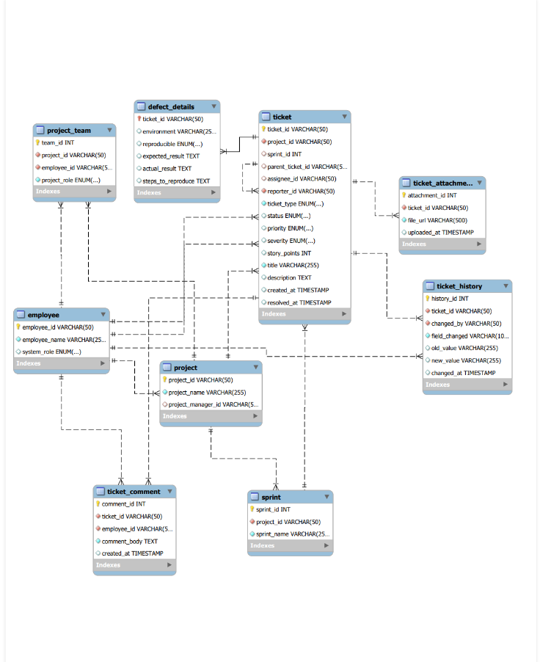
- Security Config:

package com.cts.mfrp.project_sphere.config;
@Configuration
@EnableWebSecurity
@EnableMethodSecurity // Enables @PreAuthorize
@RequiredArgsConstructor
public class SecurityConfig {
private final JwtAuthenticationFilter jwtAuthFilter;
@Bean
public SecurityFilterChain securityFilterChain(HttpSecurity http) throws Exception {
http
.csrf(AbstractHttpConfigurer::disable)
.cors(Customizer.withDefaults())
.authorizeHttpRequests(auth -> auth
.requestMatchers("/api/v1/auth/**").permitAll() .requestMatchers("/api/v1/admin/**").hasRole("ADMIN")
hasAuthority()
.anyRequest().authenticated() .anyRequest().permitAll()
)
.sessionManagement(session -> session.sessionCreationPolicy(SessionCreationPolicy.STATELESS)) .authenticationProvider(authenticationProvider)
.addFilterBefore(jwtAuthFilter, UsernamePasswordAuthenticationFilter.class);
return http.build();
}
}
- Comment controller:

3.2 Project 2: EMI Calculator

3.2.1 Project Description

The Equated Monthly Installment (EMI) Calculator was developed as a web-based financial application designed to simplify the process of loan repayment planning. In traditional scenarios, calculating EMI manually requires applying complex mathematical formulas, which can be time-consuming and prone to human error. This project was undertaken to automate the process, providing users with a reliable, accurate, and instant solution for determining their monthly loan obligations.

The application allows users to input three critical parameters — loan amount, interest rate, and loan tenure — and instantly generates the monthly EMI. By automating the computation, the tool eliminates the risk of miscalculation and ensures that users can make informed financial decisions quickly. The design philosophy behind the project was to keep the interface simple, interactive, and highly user-friendly, so that both technical and non-technical users could benefit from the tool.

Beyond its basic functionality, the EMI Calculator demonstrates the practical application of front-end technologies in solving real-world financial problems. The project was not limited to simple arithmetic; instead, it incorporated dynamic features such as real-time updates, input validation, and visual representations of loan data. For example, the calculator included a pie chart visualization to show the proportion of principal versus interest in EMI payments, and a speedometer-style indicator to represent the risk associated with taking a loan. These enhancements transformed the calculator from a basic computational tool into an engaging, interactive financial application.

The project also emphasized responsiveness and accessibility. The interface was designed to adapt seamlessly to different devices, ensuring that users could access the calculator on desktops, tablets, and mobile phones without any compromise in usability. This responsiveness made the application practical for everyday use, as financial planning often requires quick access to tools across multiple platforms.

3.2.2 Technologies Used
The EMI Calculator was developed using a combination of HTML5, CSS3, and JavaScript, which together formed a powerful front-end technology stack. Each technology played a distinct role in the application’s architecture and contributed to its overall functionality, usability, and responsiveness.

HTML5 was used to structure the layout and define the input/output fields of the calculator. It provided the semantic foundation of the application, ensuring that the interface was logically organized and accessible. Input fields for loan amount, interest rate, and tenure were created using HTML elements, while output sections were defined to display the calculated EMI. By leveraging HTML5’s semantic tags, the application achieved clarity in design and improved compatibility across browsers. The use of HTML also ensured that the calculator could be easily extended with additional features in the future, such as saving results or exporting data.
CSS3 was applied to style the application, enhance its visual appeal, and ensure responsive design across devices. CSS was used to define the layout, colors, fonts, and spacing, making the interface clean and user-friendly. Advanced CSS3 features such as media queries were implemented to adapt the design seamlessly to different screen sizes, ensuring that the calculator worked equally well on desktops, tablets, and mobile devices. This responsiveness was critical for accessibility, as financial tools are often used on-the-go. CSS also contributed to usability by highlighting active input fields, organizing sections clearly, and maintaining consistency in design across browsers.
JavaScript formed the core logic of the EMI Calculator. It was used to implement the EMI formula, handle user interactions, and dynamically update the results. Event listeners were added to capture user inputs in real time, ensuring that the EMI was recalculated instantly whenever loan parameters were adjusted. JavaScript also enabled input validation, preventing incorrect or unrealistic values from being processed. Beyond computation, JavaScript was used to integrate dynamic visualizations such as a pie chart to display the proportion of principal versus interest, and a speedometer-style indicator to represent loan risk. These interactive features transformed the calculator into a more engaging and informative tool. The use of JavaScript demonstrated how mathematical logic can be embedded into web applications to solve practical problems effectively.
Together, HTML5, CSS3, and JavaScript created a lightweight yet powerful application. HTML provided the structure, CSS ensured clarity and responsiveness, and JavaScript delivered dynamic functionality and interactivity. This combination not only made the EMI Calculator accurate and reliable but also user-friendly and visually appealing. The project highlighted the importance of integrating these technologies to build real-world applications that are both functional and accessible.

3.2.3 Work Done
- User Interface Design:
  - Created input fields for loan amount, interest rate, and tenure using HTML.
  - Designed a clean, minimal layout with CSS to ensure usability and responsiveness.

  - Applied responsive design principles so the calculator adapts seamlessly to both mobile and desktop screens.
- Logic Implementation:
  - Developed the EMI calculation formula in JavaScript.
  - Added event listeners to capture user inputs and dynamically update results.
  - Implemented input validation to handle incorrect or edge-case values, ensuring accurate outputs.
- Enhancements & Testing:
  - Integrated dynamic visualizations such as a pie chart to show the proportion of principal vs. interest.
  - Added a speedometer-style indicator to represent loan risk visually.
  - Tested the application with multiple loan scenarios to verify correctness and performance.
  - Debugged errors during development and optimized the code for smoother execution.

3.2.4 Outcomes & Learnings

Practical experience in mathematical calculations using JavaScript was one of the most valuable outcomes of this project. Implementing the EMI formula required translating theoretical mathematical concepts into executable code. This helped me strengthen my ability to break down complex formulas into smaller, logical steps that could be handled by a programming language. It also improved my confidence in applying mathematical reasoning to real-world applications, particularly in financial software development where accuracy is critical.

Strengthened skills in DOM manipulation and dynamic content rendering were another major learning. By using JavaScript to interact with the Document Object Model, I was able to capture user inputs, update results instantly, and create a dynamic interface that responded in real time. This experience taught me how to design applications that feel interactive and responsive, rather than static, and highlighted the importance of efficient DOM handling to ensure smooth performance.

Improved knowledge of responsive web design and cross-device compatibility was achieved by designing the EMI Calculator to adapt seamlessly to desktops, tablets, and mobile devices. Using CSS3 media queries and flexible layouts, I ensured that the application maintained usability and clarity across different screen sizes. This reinforced the importance of accessibility in modern web development, as users expect tools to work consistently across all platforms.

Learning to integrate visual elements such as charts and indicators to enhance user experience was another key outcome. Adding a pie chart to display the proportion of principal versus interest and a speedometer-style indicator to represent loan risk transformed the calculator from a simple computational tool into a visually engaging application. These features demonstrated how visual aids can make complex financial data easier to understand and emphasized the role of design thinking in software development.

Finally, I developed confidence in building real-world financial applications with front-end technologies. By combining HTML, CSS, and JavaScript, I was able to create a tool that solved a practical problem faced by many individuals. This boosted my confidence in applying my technical skills to real-world scenarios and showed me how even simple applications can have meaningful impact when designed thoughtfully

3.2.5 Skills Gained During Internship
- Web Application Development
- JavaScript DOM Manipulation
- Responsive Web Design
- CRUD Operations (from Project 1)
- Problem Solving & Logical Thinking
- Debugging and Testing

3.2.6 Tasks Assigned During Internship
- Developed Employee Management System (full-stack project)
- Built EMI Calculator using JavaScript
- Implemented responsive UI design across projects
- Tested application functionality with multiple scenarios
- Debugged errors and improved performance

3.2.7 Code Implementation
Project EMI Calculator:
const pairs = [
{ num: 'amountnum', range: 'amountrange' },
{ num: 'interestnum', range: 'interestrange' },
{ num: 'tenurenum', range: 'tenurerange' }
];

pairs.forEach(pair => {
const num = document.getElementById(pair.num); const range = document.getElementById(pair.range);
num.addEventListener("input", () => { range.value = num.value; });
range.addEventListener("input", () => { num.value = range.value; });
});

//2. Global Chart Instances let barChartInstance = null; let pieChartInstance = null;

//3. Master Calculate Function function calculateAll()
{
const P = parseFloat(document.getElementById('amountnum').value);
const annualRate = parseFloat(document.getElementById('interestnum').value); const n = parseInt(document.getElementById('tenurenum').value);

if (isNaN(P) || P < 10000 || P > 10000000) {
alert("Invalid Loan Amount. Please enter a value between ₹10,000 and ₹1,00,00,000 (1 Crore)."); return;

}
if (isNaN(annualRate) || annualRate < 1 || annualRate > 25) {
alert("Invalid Interest Rate. Please enter a value between 1% and 25%."); return;
}
if (isNaN(n) || n < 1 || n > 360) {
alert("Invalid Payment Term. Please enter a value between 1 and 360 months."); return;
}
const r = annualRate / 12 / 100;
const emi = P * r * Math.pow(1 + r, n) / (Math.pow(1 + r, n) - 1); const totalPayment = emi * n;
const totalInterest = totalPayment - P;

document.getElementById('emiDisplay').value = emi.toLocaleString('en-IN',
{minimumFractionDigits: 2, maximumFractionDigits: 2});
updateSpeedometer(P); updatePieChart(P, totalInterest); updateBarChart(P, r, n, emi); generateTable(P, r, n, emi);
document.getElementById('pdfBtn').style.display = "block";
}
//4. Speedometer / Loan Category Logic function updateSpeedometer(amount) { let categoryName = "Small Loan";
let rotation = -90;
if (amount <= 500000)

else if (amount <= 2500000)
{
categoryName = "Medium Loan (₹5L - ₹25L)"; rotation = -45 + ((amount - 500000) / 2000000) * 45;
}
else if (amount <= 10000000)
{
categoryName = "Large Loan (₹25L - ₹1Cr)"; rotation = 0 + ((amount - 2500000) / 7500000) * 45;
}
else
{
categoryName = "Mega Loan (₹1Cr+)";
rotation = 45 + Math.min(((amount - 10000000) / 50000000), 1) * 45;
}

document.getElementById('needle').style.transform = `translateX(-50%) rotate(${rotation}deg)`; document.getElementById('categoryName').innerText = categoryName;
}
//5. Pie Chart Logic
function updatePieChart(principal, interest) {
const ctx = document.getElementById('pieChart').getContext('2d');
if (pieChartInstance) pieChartInstance.destroy();
pieChartInstance = new Chart(ctx, { type: 'pie',
data: {
labels: ['Principal Amount', 'Total Interest'], datasets: [{
data: [principal, interest],

backgroundColor: ['#355872', '#9CD5FF'], borderColor: '#ffffff',
borderWidth: 2
}]
},
options: { responsive: true,
maintainAspectRatio: false,
plugins: { legend: { position: 'bottom' } }
}
});
}
//6. Bar Chart Logic
function updateBarChart(P, r, n, emi) {
const ctx = document.getElementById('barChart').getContext('2d');
const labels = [], principalArr = [], interestArr = [], balanceArr = []; let balance = P;
for (let m = 1; m <= n; m++)
{
let interest = balance * r;
let principal = emi - interest;
if (m === n)
{
principal = balance; balance = 0;
}
else
{
balance -= principal;
}

labels.push(String(m)); principalArr.push(principal.toFixed(0)); interestArr.push(interest.toFixed(0));
balanceArr.push(Math.max(0, balance).toFixed(0));
}
if (barChartInstance) barChartInstance.destroy();
barChartInstance = new Chart(ctx, { type: 'bar',
data: {
labels: labels, datasets: [
{
label: 'Principal', data: principalArr,
backgroundColor: '#355872',
stack: 'Stack 1',
yAxisID: 'y' // Link to left axis
},
{
label: 'Interest', data: interestArr,
backgroundColor: '#9CD5FF', stack: 'Stack 1',

yAxisID: 'y' // Link to left axis
},
{
label: 'Remaining Balance', data: balanceArr,
type: 'line', borderColor: '#d63031',
backgroundColor: 'transparent', fill: false,
pointRadius: 0,
borderWidth: 2.5, yAxisID: 'y1'
}
]
},
options: { responsive: true,
maintainAspectRatio: false, interaction: {
mode: 'index', intersect: false,
},
stacked: true
},
y: {
stacked: true, beginAtZero: true, position: 'left',
title: { display: true, text: 'Monthly Payment (₹)' }},

y1: {
beginAtZero: true, position: 'right',
title: { display: true, text: 'Remaining Balance (₹)' }, grid: {
drawOnChartArea: false
}
}
}
}
});
}
//7. Amortization Table Logic function generateTable(P, r, n, emi) {
const tableBody = document.getElementById('tableBody');
tableBody.innerHTML = "";

while (monthsProcessed < n) {
let currentCalendarYear = currentDate.getFullYear();
let yearlyInterest = 0, yearlyPrincipal = 0, yearlyTotalPayment = 0; let monthRows = "";

3.2.8 Result
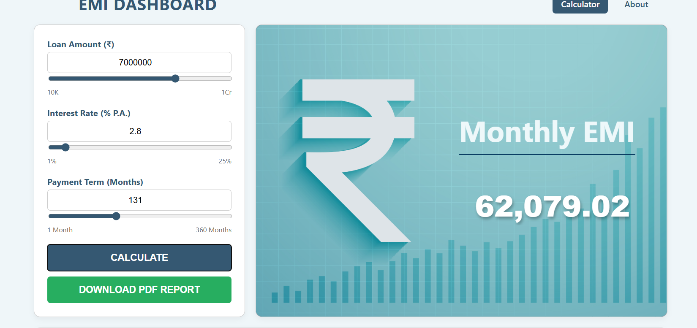
Figure 3.2.1 Calculating Monthly EMI

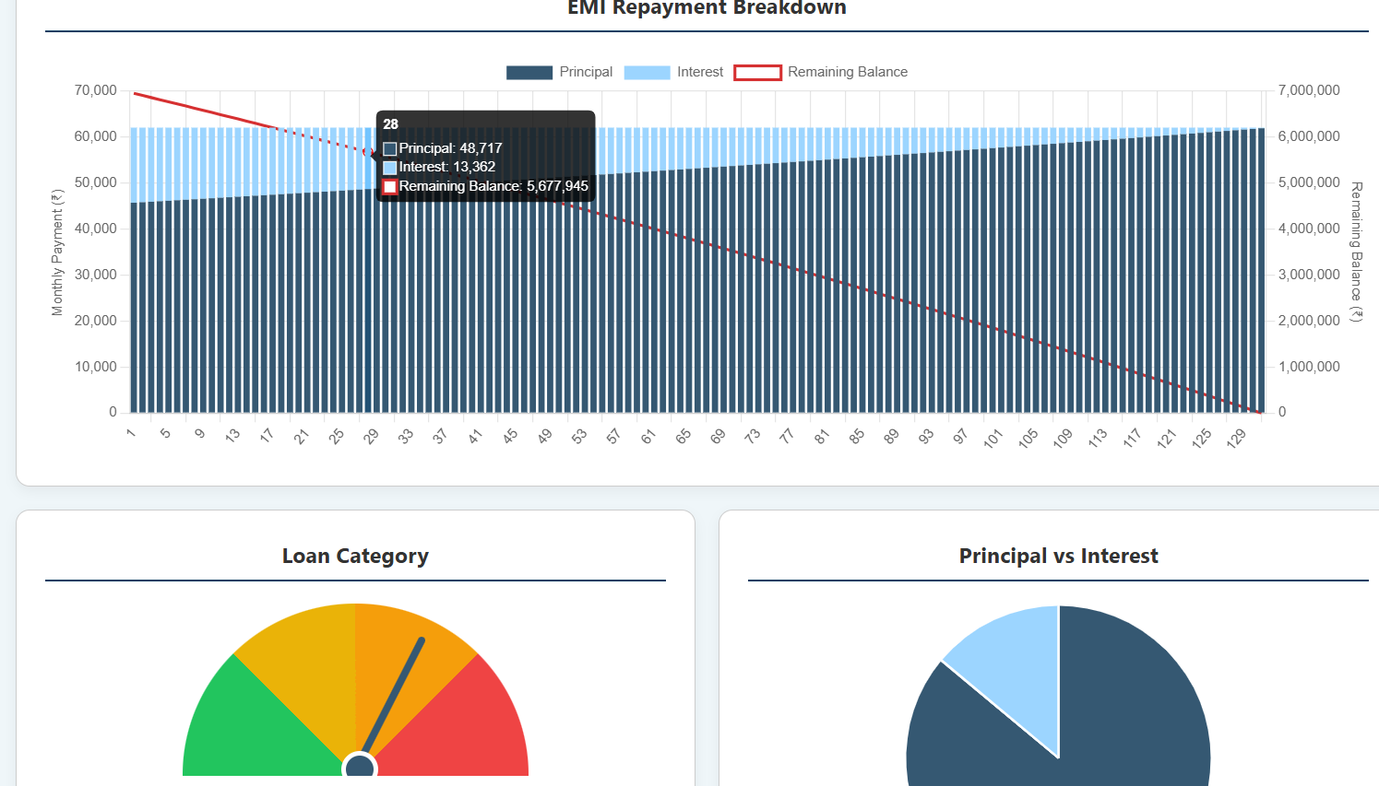
Figure 3.2.2 Bar Graph Representation of Monthly EMI

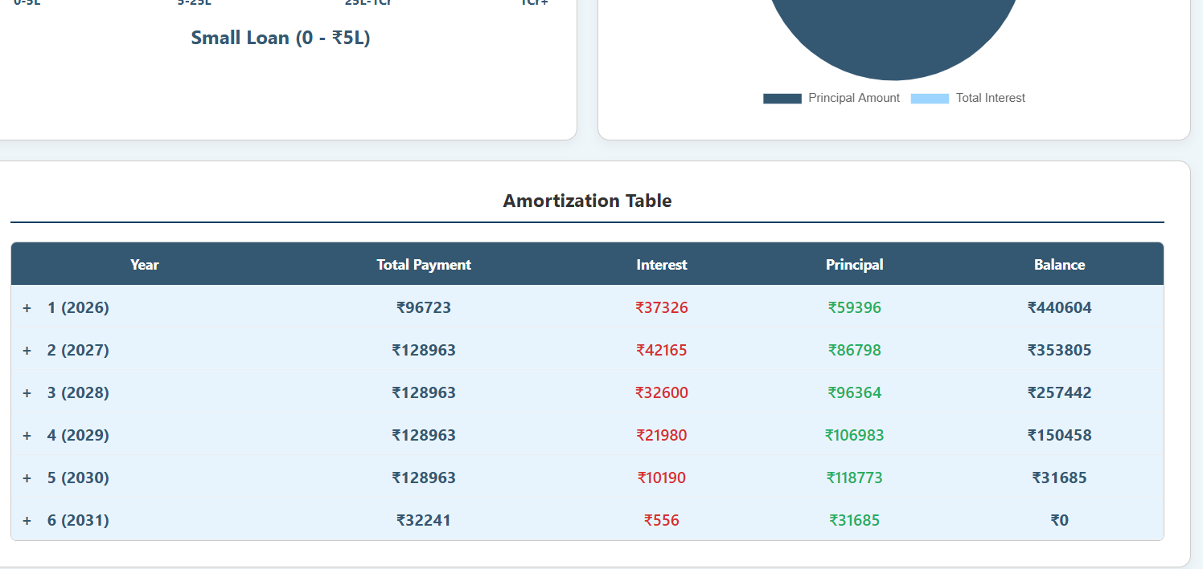

Figure 3.2.3 Amortization Table of Monthly EMI
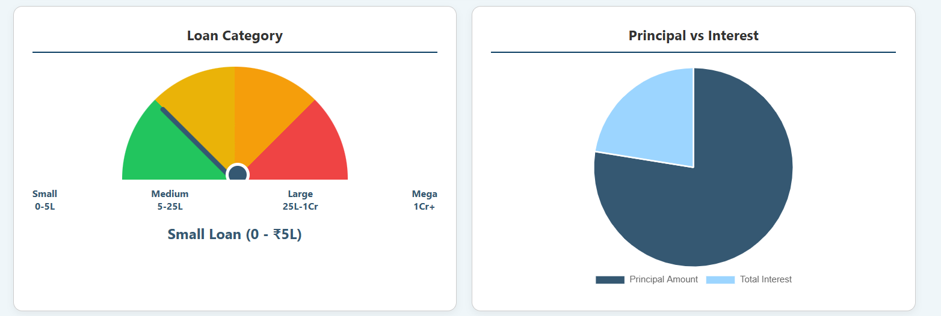

Figure 3.2.4 Speedometer and piechart

Project 3: Employee Management System Abstract
The Employee Management System (EMS) is a full-stack web application designed to streamline employee and department management within an organization. It provides functionalities such as adding new employees, updating existing records, deleting employee data, and viewing employee information. The primary objective is to simplify employee data handling, reduce manual errors, and improve accessibility through a structured, user-friendly interface.

3.3.1 Introduction
Manual employee record management is inefficient, error-prone, and difficult to scale. The EMS project was developed to automate these processes, enabling administrators to perform CRUD operations seamlessly. The system integrates a relational database to ensure secure storage and quick retrieval of information.

3.3.2 Architecture & Modules
- Frontend (React):
  - Forms for adding/updating employee details.
  - Navigation menus for accessing modules.
  - Input validation for accurate data entry.
- Backend (Spring Boot):
  - RESTful APIs for CRUD operations.
  - Business logic for managing employee and department records.
  - Error handling and validation layers.
- Database (MySQL):
  - Tables for employees and departments.
  - Relationships defined for structured data storage.
  - Queries optimized for fast retrieval.

3.3.3 Outcomes & Learnings
- Strengthened knowledge in full-stack development.
- Gained practical experience in API design and integration.
- Improved understanding of database schema design and relational integrity.
- Enhanced debugging and testing skills.

Comparative Analysis
Aspect | Employee Management System (EMS) | EMI Calculator
Domain | Enterprise data management | Financial calculations
Objective | Automate employee record handling | Simplify EMI computation
Technologies Used | React, Spring Boot, MySQL | HTML, CSS, JavaScript
Key Features | CRUD operations, department-wise data | Dynamic EMI calculation, charts, risk indicator
Focus Area | Full-stack development, database integration | Front-end logic, responsive UI
Skills Gained | API design, schema modeling, debugging | DOM manipulation, validation, visualization
Outcome | Industry-ready enterprise solution | User-friendly financial tool

3.3.4 Code Implementation:
package net.javaguides.ems.controller;
import lombok.AllArgsConstructor;
import net.javaguides.ems.dto.DepartmentDto;
import net.javaguides.ems.service.DepartmentService; import org.springframework.http.HttpStatus;
import org.springframework.http.ResponseEntity; import org.springframework.web.bind.annotation.*;

import java.util.List;
@CrossOrigin("*") @AllArgsConstructor @RestController @RequestMapping("/api/departms")
public class DepartmentController {
private DepartmentService departmentService;
// Build Create or Add Department REST API @PostMapping
public ResponseEntity<DepartmentDto> createDepartment(@RequestBody DepartmentDto departmentDto){
DepartmentDto department = departmentService.createDepartment(departmentDto); return new ResponseEntity<>(department, HttpStatus.CREATED);
}

// Build Get Department REST API@GetMapping("{id}")
public ResponseEntity<DepartmentDto> getDepartmentById(@PathVariable("id") Long departmentId){
DepartmentDto departmentDto = departmentService.getDepartmentById(departmentId); return ResponseEntity.ok(departmentDto);
}

// Build Get All Departments REST API @GetMapping
public ResponseEntity<List<DepartmentDto>> getAllDepartments(){ List<DepartmentDto> departments = departmentService.getAllDepartments(); return ResponseEntity.ok(departments);
}

// Build Update Department REST API @PutMapping("{id}")
public ResponseEntity<DepartmentDto> updateDepartment(@PathVariable("id") Long departmentId,
@RequestBody DepartmentDto updatedDepartment){ DepartmentDto departmentDto = departmentService.updateDepartment(departmentId,updatedDepartment);
return ResponseEntity.ok(departmentDto);
}

// Build Delete Department REST API @DeleteMapping("{id}")
public ResponseEntity<String> deleteDepartment(@PathVariable("id") Long departmentId){ departmentService.deleteDepartment(departmentId);
return ResponseEntity.ok("Department deleted successfully!.");
}
}

package net.javaguides.ems.controller;
import lombok.AllArgsConstructor;
import net.javaguides.ems.dto.EmployeeDto;
import net.javaguides.ems.service.EmployeeService; import org.springframework.http.HttpStatus;
import org.springframework.http.ResponseEntity; import org.springframework.web.bind.annotation.*;
import java.util.List;

@CrossOrigin("*") @AllArgsConstructor @RestController @RequestMapping("/api/employees") public class EmployeeController {
private EmployeeService employeeService;
// Build Add Employee REST API @PostMapping
public ResponseEntity<EmployeeDto> createEmployee(@RequestBody EmployeeDto employeeDto)

EmployeeDto savedEmployee = employeeService.createEmployee(employeeDto); return new ResponseEntity<>(savedEmployee, HttpStatus.CREATED);
}

// Build Get Employee REST API @GetMapping("{id}")
public ResponseEntity<EmployeeDto> getEmployeeById(@PathVariable("id") Long employeeId){ EmployeeDto employeeDto = employeeService.getEmployeeById(employeeId);
return ResponseEntity.ok(employeeDto);
}
// Build Get All Employees REST API @GetMapping
public ResponseEntity<List<EmployeeDto>> getAllEmployees(){ List<EmployeeDto> employees = employeeService.getAllEmployees(); return ResponseEntity.ok(employees);
}
// Build Update Employee REST API @PutMapping("{id}")
public ResponseEntity<EmployeeDto> updateEmployee(@PathVariable("id") Long employeeId,
@RequestBody EmployeeDto updatedEmployee){
EmployeeDto employeeDto = employeeService.updateEmployee(employeeId, updatedEmployee); return ResponseEntity.ok(employeeDto);
}

// Build Delete Employee REST API @DeleteMapping("{id}")
public ResponseEntity<String> deleteEmployee(@PathVariable("id") Long employeeId){ employeeService.deleteEmployee(employeeId);
return ResponseEntity.ok("Employee deleted successfully!.");
}
}

@NoArgsConstructor @AllArgsConstructor @Entity
@Table(name = "employees") public class Employee {

@Id
@GeneratedValue(strategy = GenerationType.IDENTITY) private Long id;

@Column(name = "first_name") private String firstName;

@Column(name = "last_name") private String lastName;

@Column(name = "email_id", nullable = false, unique = true) private String email;

@ManyToOne(fetch = FetchType.LAZY) @JoinColumn(name = "department_id") private Department department;
}
package net.javaguides.ems.entity;

import jakarta.persistence.*;
import lombok.AllArgsConstructor;
import lombok.Getter;
import lombok.NoArgsConstructor;
import lombok.Setter;

@Getter
@Setter
@NoArgsConstructor
@AllArgsConstructor
@Entity
@Table(name = "departments")
public class Department {

@Id
@GeneratedValue(strategy = GenerationType.IDENTITY)
private Long id;
@Column(name = "department_name")
private String departmentName

@Column(name = "department_description")
private String departmentDescription;
}

package net.javaguides.ems.mapper;
import net.javaguides.ems.dto.DepartmentDto;
import net.javaguides.ems.entity.Department;
public class DepartmentMapper { // convert department jpa entity into department dto
public static DepartmentDto mapToDepartmentDto(Department department){
return new DepartmentDto(
department.getId(),
department.getDepartmentName(),
department.getDepartmentDescription() );
} // convert department dto into department jpa entity
public static Department mapToDepartment(DepartmentDto departmentDto){
return new Department(
departmentDto.getId(),
departmentDto.getDepartmentName(),
departmentDto.getDepartmentDescription()
);
}}

package net.javaguides.ems.repository;
import net.javaguides.ems.entity.Department;
import org.springframework.data.jpa.repository.JpaRepository;
public interface DepartmentRepository extends JpaRepository<Department, Long> {
}
package net.javaguides.ems.service.impl;
import lombok.AllArgsConstructor;
import net.javaguides.ems.dto.DepartmentDto;
import net.javaguides.ems.entity.Department;
import net.javaguides.ems.exception.ResourceNotFoundException;
import net.javaguides.ems.mapper.DepartmentMapper;
import net.javaguides.ems.repository.DepartmentRepository;
import net.javaguides.ems.service.DepartmentService;
import org.springframework.stereotype.Service;
import java.util.List;
import java.util.stream.Collectors;
@Service
@AllArgsConstructor
public class DepartmentServiceImpl implements DepartmentService {
private DepartmentRepository departmentRepository;
@Override
public DepartmentDto createDepartment(DepartmentDto departmentDto) {
Department department = DepartmentMapper.mapToDepartment(departmentDto);
Department savedDepartment = departmentRepository.save(department);
return DepartmentMapper.mapToDepartmentDto(savedDepartment);
}
@Override
public DepartmentDto getDepartmentById(Long departmentId) {
Department department = departmentRepository.findById(departmentId).orElseThrow(
() -> new ResourceNotFoundException("Department is not exists with a given id: " + departmentId)
);
return DepartmentMapper.mapToDepartmentDto(department);
}
@Override
public List<DepartmentDto> getAllDepartments() {
List<Department> departments = departmentRepository.findAll();
return departments.stream().map((department) -> DepartmentMapper.mapToDepartmentDto(department))
.collect(Collectors.toList());
}
@Override
public DepartmentDto updateDepartment(Long departmentId, DepartmentDto updatedDepartment) {
Department department = departmentRepository.findById(departmentId).orElseThrow(
() -> new ResourceNotFoundException("Department is not exists with a given id:"+ departmentId)
);
department.setDepartmentName(updatedDepartment.getDepartmentName());
department.setDepartmentDescription(updatedDepartment.getDepartmentDescription());
Department savedDepartment = departmentRepository.save(department);
return DepartmentMapper.mapToDepartmentDto(savedDepartment);
}
@Override
public void deleteDepartment(Long departmentId) {
departmentRepository.findById(departmentId).orElseThrow(
() -> new ResourceNotFoundException("Department is not exists with a given id: " + departmentId)
);
departmentRepository.deleteById(departmentId);
}
}

3.3. 4 Results
Employee Management System:

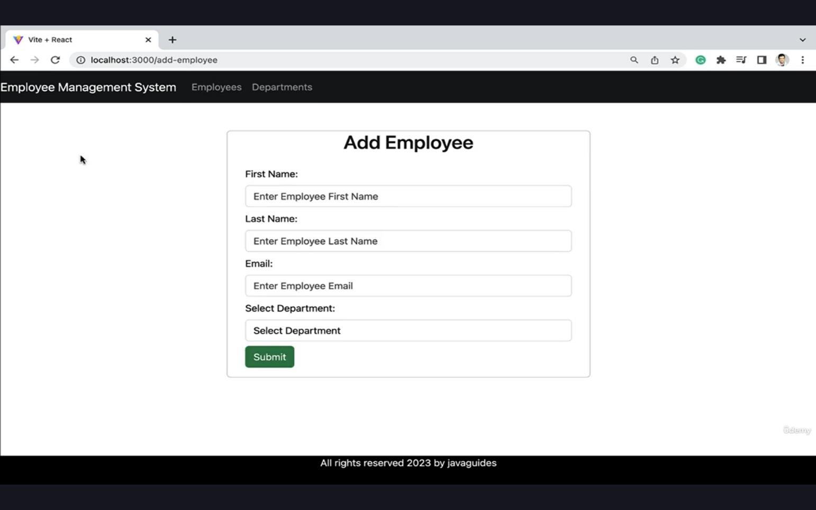

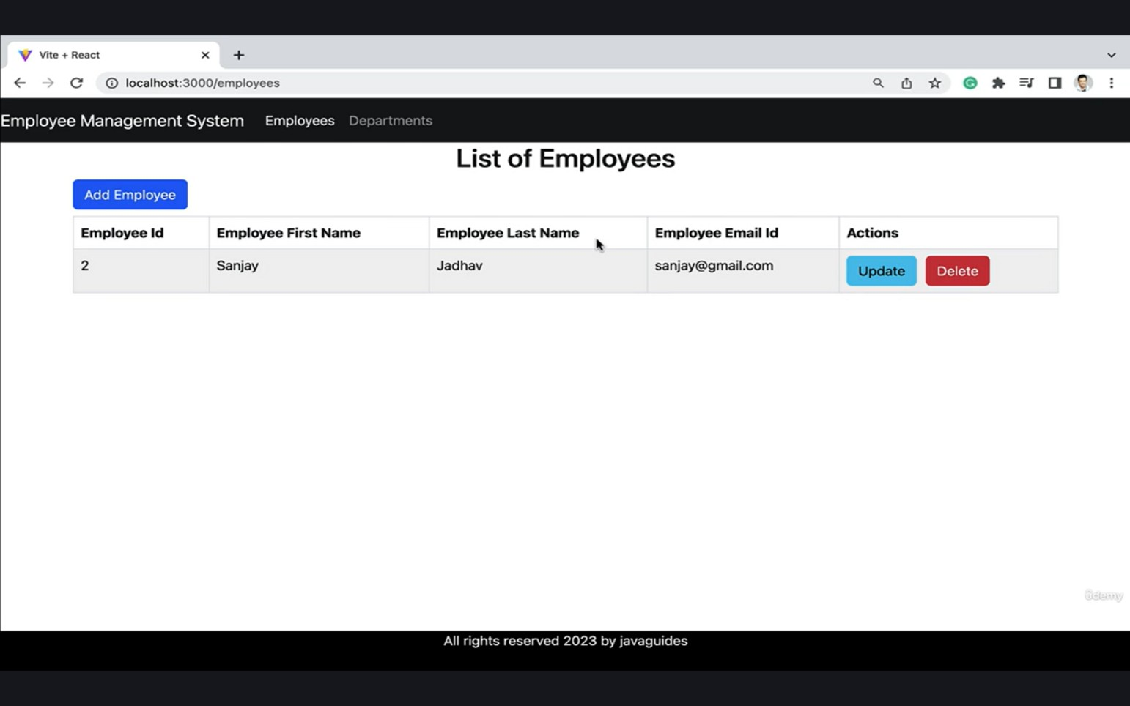
Figure 3.3.1 Adding Employee Details

Figure 3.3.2 Displaying Details

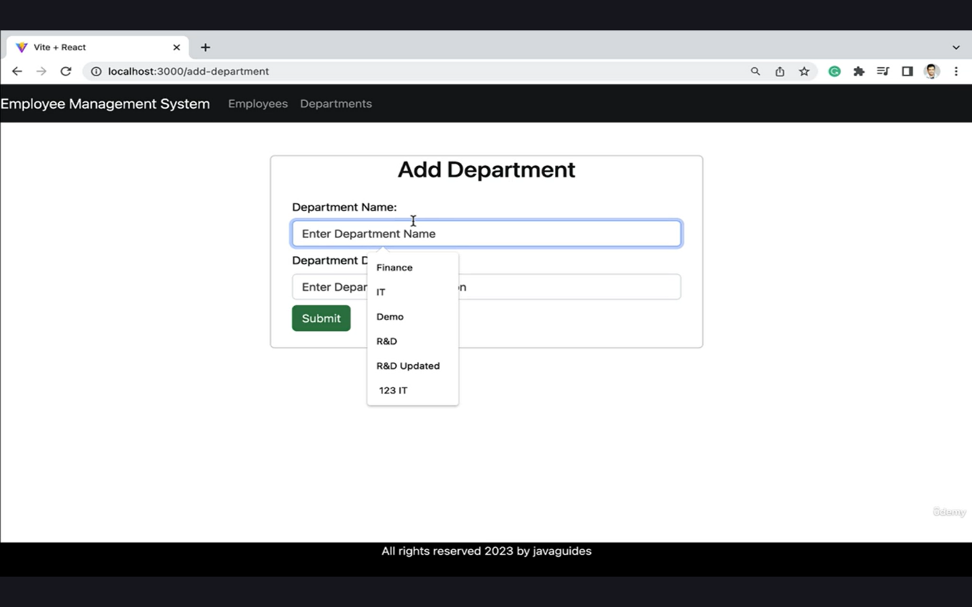
Figure 3.3.3 Adding Department Details

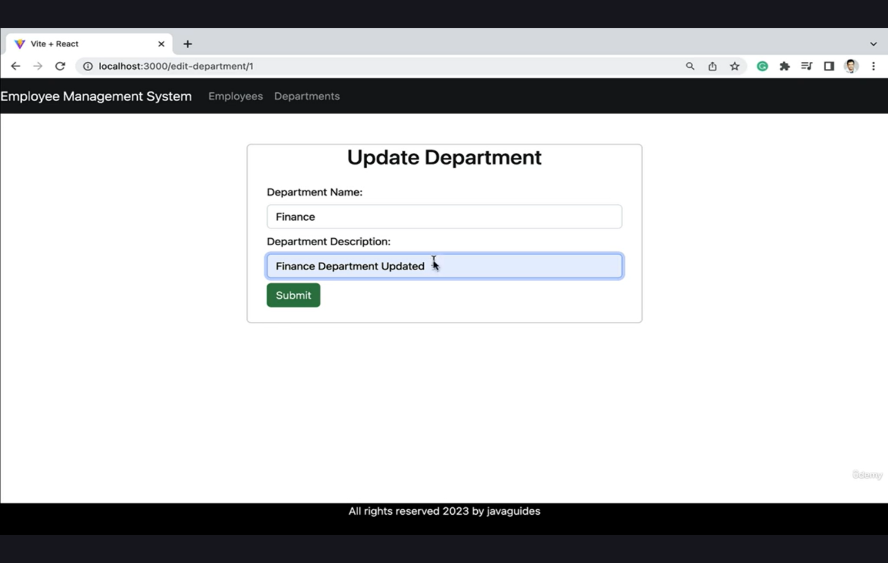
Figure 3.3.4 Updating Department Details
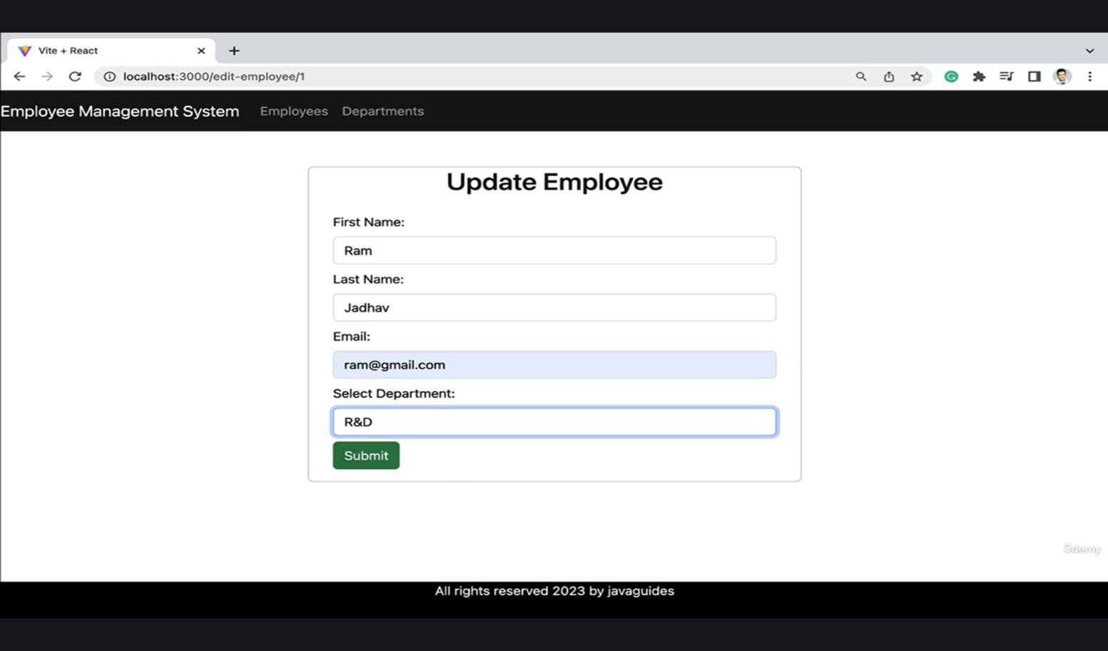

Figure 3.3.5 Updating Employee Details

ACTIVITY LOG FOR THE WEEK

weeks | Description of the weekly activity | Learning Outcome | Person In- Charge Signature
Week 1 | Attended internship orientation session, understood organization workflow, discussed project guidelines, and installed required software such as code editor and browser tools. | Gained understanding of internship objectives, development environment setup, and basic workflow of web development projects.
Week-2 | Learned HTML fundamentals including tags, forms, tables, and semantic elements. Created basic static web pages for practice. | Acquired knowledge of HTML structure and ability to design simple webpages.
Week 3 | Studied advanced HTML5 concepts, semantic elements, and form controls. Started designing sample web layouts. | Learned advanced HTML concepts and improved page structuring skills.
Week 4 | Learned CSS fundamentals including selectors, box model, layout, background, text styling, and animations. | Acquired skills in styling webpages using CSS.

Week 5 | Studied CSS Grid and layout design. Introduction to Bootstrap and created responsive layouts using Bootstrap components. | Learned responsive design and layout management.
Week 6 | Created sample portfolio webpage with header, footer, hero section, and responsive design using Bootstrap. | Gained experience in building responsive web pages.
Week 7 | Introduction to JavaScript, variables, data types, operators, control statements, and basic calculator implementation. | Learned JavaScript fundamentals and logic building.
Week 8 | Studied functions, arrays, objects, loops, and DOM manipulation. Implemented interactive elements using JavaScript. | Improved DOM manipulation and dynamic webpage development skills.
Week 9 | Learned JavaScript OOP concepts, constructors, inheritance, and events handling. Worked on background generator exercise. | Gained knowledge of advanced JavaScript concepts.
Week 10 | Introduction to jQuery and Node.js. Learned modules, Express framework, and RESTful APIs. | Understood backend basics and server-side development.
Week 11 | Studied Database and SQL concepts including create table, insert, update, delete, and join operations. | Learned database management and SQL queries.
Week 12 | Major project discussion and development of Employee Management System and EMI Calculator. Final testing and documentation preparation. | Gained practical experience in real-time project development and documentation.

CONCLUSION

During the course of my internship, I successfully completed two major projects: the Employee Management System and the EMI Calculator. These projects provided me with the opportunity to apply the theoretical concepts learned during training in a practical and real-world environment. By working on these applications, I was able to bridge the gap between academic knowledge and industry practices, gaining valuable hands-on experience in web development.

While working on the Employee Management System, I gained extensive exposure to full-stack development. I designed user interfaces using React, implemented CRUD operations through Spring Boot, and integrated a relational database using MySQL. This project helped me understand the importance of structured application development, modular design, and the separation of concerns between frontend, backend, and database layers. It also improved my ability to manage employee data efficiently, ensuring accuracy and reliability. The EMS project strengthened my skills in responsive design, API development, and database schema modeling, which are essential for building scalable enterprise-level applications.

The EMI Calculator project, on the other hand, focused primarily on front-end development and mathematical logic implementation. By using HTML, CSS, and JavaScript, I was able to design an interactive interface that allowed users to input loan details and instantly view EMI results. This project taught me how to handle user inputs effectively, perform dynamic calculations in real time, and display results in a clear and user-friendly manner. I also learned how to integrate visual elements such as charts and indicators to enhance user experience, making financial data easier to interpret. The EMI Calculator improved my skills in DOM manipulation, event handling, and responsive web design, while also boosting my confidence in developing lightweight, practical tools for everyday use.

Overall, working on these two projects significantly improved my technical knowledge, problem-solving ability, and debugging skills. The internship provided me with a strong foundation in both frontend and backend development, allowing me to understand the complete workflow of real-time project implementation. It also gave me insight into industry practices such as testing, validation, and optimization, which are crucial for delivering reliable applications.

Most importantly, this internship increased my confidence in developing user-friendly and responsive web applications. By successfully completing both projects, I demonstrated my ability to work with modern technologies, adapt to challenges, and deliver functional solutions. The experience has prepared me to take on more complex projects in the future and has strengthened my readiness for professional roles in the field of web development.

References

- https://ssrn.com/abstract=4887926
- https://link.springer.com/article/10.1007/s00521-021-06853-3
- https://www.sciencedirect.com/science/article/pii/S095070512300655X
- https://eudl.eu/doi/10.4108/eai.18-11-2022.2327121
- https://www.sciencedirect.com/science/article/pii/S2352711025000731
- https://arxiv.org/abs/1706.10059
- https://arxiv.org/abs/2409.08426
- https://arxiv.org/abs/2210.01774
- https://arxiv.org/abs/1808.09940
- https://arxiv.org/abs/1706.10059
- https://www.geeksforgeeks.org/machine-learning/function-approximation-in-reinforcement- learning/

